MSWORD TEMPLATE FOR ICEFSI SHORT PAPER
Instructions for authors

A. Author1^{(1)*}, B. Author2^{(2,3)} and C. Author3⁽³⁾

⁽¹⁾ Univ or Inst, Lab or Dep, Country (Affiliation of author A)
⁽¹⁾ Univ or Inst, Lab or Dep, Country (Affiliation of author A)
⁽³⁾ Other affiliation Univ / Ins, Lab / Dep, Country
* Corresponding author: firstname.lastname@entity.org

Abstract
Authors are invited to write their ICEFSI short paper in English using the present MsWord template (or LaTex template). The manuscript of four (04) pages should contain an abstract of a maximum of 150 words, a body text divided into sections, and a conclusion. The abstract must highlight the purpose of the paper, the methodology of the study, the findings, the main results and their scientific relevance. The ICEFSI extended abstracts will be indexed in databases, they should be well written and convey all significant aspects of the proposed work. All the submissions will be peer-reviewed and evaluated based on originality, technical content, research novelty, and relevance to the conference themes. Selected presentations during the conference will be proposed for paper publication in a partner journal.
Keywords: ICEFI, Bejaia, Template, Instructions, LaTex, MsWord.

Introduction
The main font of the manuscript is "Times New Roman" with 11pt size and simple line spacing. The margins are fixed to 2cm for the four sides of all pages and the text alignment is justified. The following sections describe detail of the text formatting.

Manuscript content
Papers include the title, author affiliation, abstract, and possibly nomenclature, and introduction, body of the paper, conclusion, references, figures (high resolution) and original tables. A paper may also include appendices and acknowledgements.

Title of the manuscript
The title of the paper is centered, it is written in capital letters and in "Times New Roman" bold fonts and size 14pt. A subtitle can be added in same font and size but in italic shape.

Authors and Affiliations
Authors' names should be written in "Times New Roman" font, bold and in 12pt size. The initial(s) of the first name(s) followed by the last name of each author should appear. If two or more authors have the same affiliation, the name of the organization should not be repeated after each name. Titles such as Mr., Mrs., Ms., Prof., or Dr. are not accepted.

Sections
The sections headings are in "Times New Roman" 12pt boldface with 12 points spacing before and 6 points after. All sections headings, except “Abstract” and “References”, are sequentially numbered and may contain only one level of subsection numbering.

Sub-sections
The subsections headings are in boldface with 6 points spacing before and no extra spacing after. Sub-sub-sections are not allowed.

Nomenclature
A nomenclature may be inserted in the paper to detail the symbols used in the manuscript, their definitions and their units in the international system. The nomenclature should be organized in alphabetical order with the Greek symbols placed after the Latin alphabetical symbols. Subscripts and superscripts should follow the Greek symbols.

Figures
All figures must be cited in the body of the paper. They must be numbered in Arabic numerals according to the order in which they appear in the text. A figure must be inserted in the text by choosing the layout option "Aligned with text" and be centered. The figure caption must also be centered and must be written below the figure in 10pt font. Multiple figures may be labeled with a separate number and letters (e.g., Figures 1a through 1d). Figures may be in black and white or color and must have a minimum resolution of 300 dpi. They should be small but clearly readible.

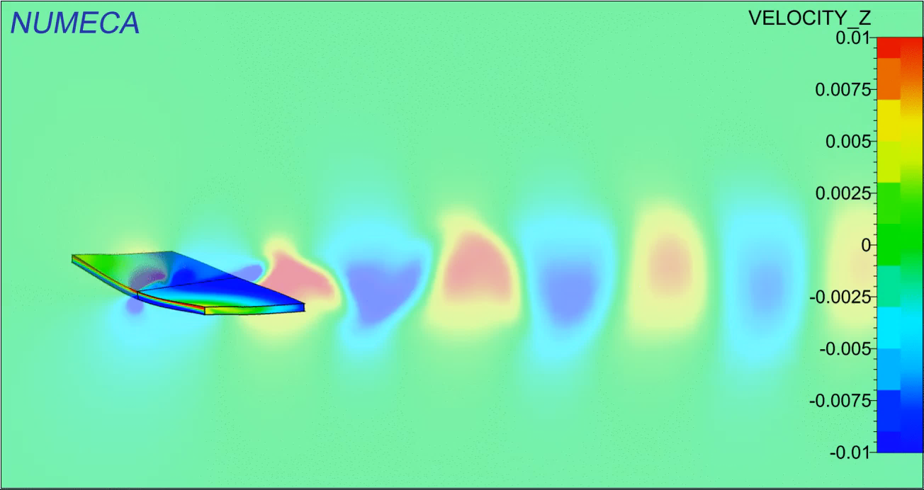

Figure 1. Example of a figure

Tables
All tables should be cited in the body of the paper. Tables should be numbered in Arabic numerals according to the order in which they appear in the text. Tables should be as small as possible (i.e., small cell widths and heights) and centered on the page. Line and column headings should be as concise as possible. The caption of a table should also be centered and should be written below the table. Headings should be written in "Times New Roman" font, bold, 10pt size, centered. The content of the tables will be written with a 10pt font size (see example Table 1 below).

Brand | Size | Value | Standard (mm)
A | 225 | 697 | 696
B | 225 | 697 | 696

Table 1. Example of a table

Mathematical notations and equations
To avoid editing and typographical errors, authors should clearly identify subscripts, superscripts, Greek letters and other symbols. Equations should be numbered using Arabic numerals placed in parentheses. The conventional order of parentheses is [{(0)}]. Here is an example of an equation numbered Equation 1.
It is recommended to use table with no borders to center equation and left align the number.

$$E=mC^{2}$$ | (1)

with $E$ the energy in J, $m$ the mass of the solid in kg, $C$ the speed of light in m/s.

Units and Abbreviations
Units should be expressed in the International System of Units. Acronyms and abbreviations should be defined the first time they appear in the text.

Acknowledgements
Acknowledgements should be written in "Times New Roman" font, 10pt size and justified alignment.

References
References should be included at the end of the manuscript in a separate section entitled References. References are numbered and should be listed in the order in which the citations appear in the body of the text. References must be complete and accurate. The order of information is as follows: name and initials of all authors, year of publication, title of paper, report, or chapter (in quotation marks), title of book or journal (in italics), volume and number, name of publisher and place of publication (for books), name and place of conference (for proceedings), and page numbers. See examples below [1], [2], [3].

References
- V. Nguyen, S. Guillou, J. Thiébot and A. Santa Cruz, “Numerical simulation of a pilot tidal farm using actuator disks, influence of a time-varying current direction,” in Grand Renewable Energy 2014 Proceeding, Tokyo, Japan, 2014.
- T. Roc, D. Greaves, K. Thyng, and D. Conley, “Tidal turbine representation: towards realistic applications,” Ocean Engineering, vol. 78, pp. 95-111, 2014.
- R. Rajagopalan and J. Fanucci, “Finite difference model for vertical-axis wind turbines,” AIAA Journal of Propulsion and Power, vol. 1, pp. 432-436, 1985.

